* Read CSV file using csv.reader
* Read CSV file using .readlines() function
* Read CSV file using Pandas
* Read CSV file using csv.DictReader

Read csv file using csv.reader:

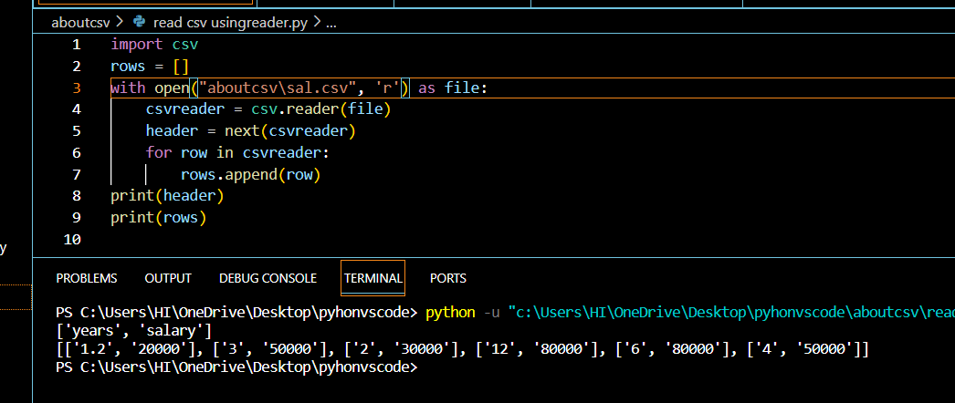

Read csv using readline function:

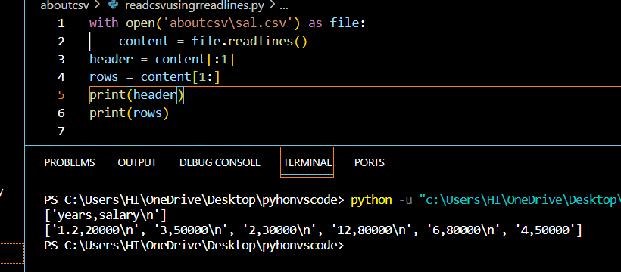

Read csv using pandas:

Read csv using csv.Dictreader():

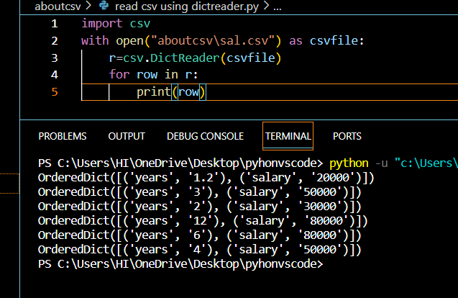

* **Write CSV file using csv.writer**
* **Write CSV file using writelines() function**
* **Write CSV file using Pandas**
* **Write CSV file using csv.DictWriter**

**Write CSV file using csv.writer:**

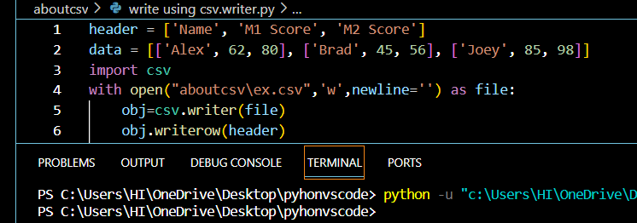

**Write CSV file using writelines() function:**

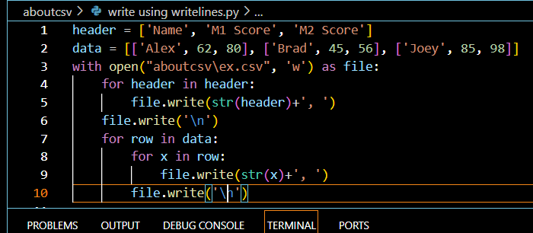

**Write CSV file using Pandas:**

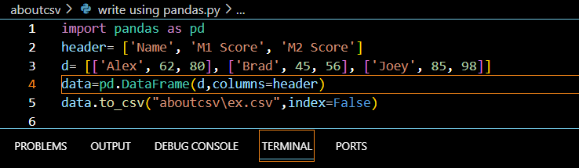

**Write CSV file using csv.DictWriter:**

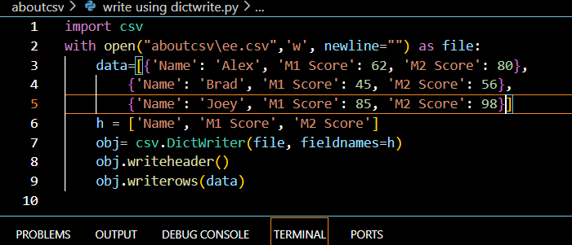

Csv to list using pandas:

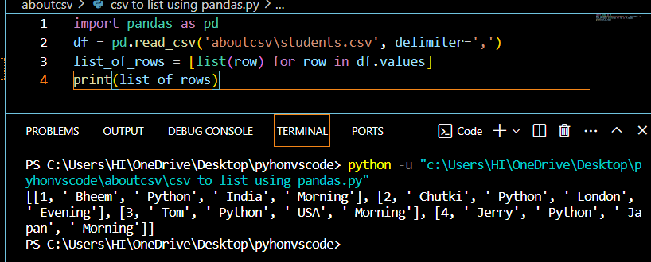

Dictionary to json:

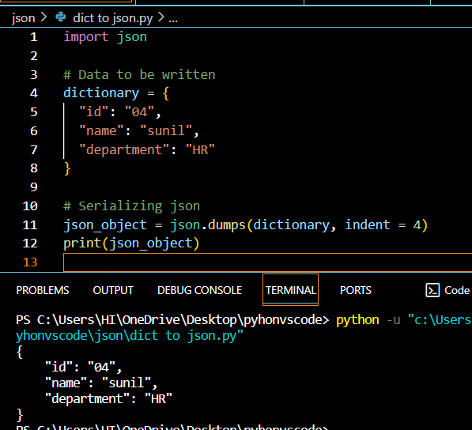

Json string to dict:

